Troubleshooting

dpkg -l | grep -E ".(opensearch|graylog|mongo)."

Searching packages and their version

**Error:**

grep -E "WARN|ERR" /var/ossec/logs/ossec.log

11:03:23 wazuh-modulesd:content-updater: ERROR: Action for 'vulnerability_feed_manager' failed: Orchestration run failed: Error -1 from server: Failure when receiving data from the peer

2024/07/07 12:04:41 wazuh-modulesd:content-updater: ERROR: Action for 'vulnerability_feed_manager' failed: Orchestration run failed: Error -1 from server: SSL connect error

**Sol:** Change ip in ossec.conf file

**Error: Agent not displaying in wazuh dashboard**

Checking connection with manager

# nc -zv 192.168.198.129 1514 1515 55000

192.168.198.129: inverse host lookup failed: Host name lookup failure

(UNKNOWN) [192.168.198.129] 1514 (?) open

(UNKNOWN) [192.168.198.129] 1515 (?) open

(UNKNOWN) [192.168.198.129] 55000 (?) open

No connection with manager

. changing 1514 port to 1515 tcp in ossec.conf nope don’t wazuh-manager stops

. checking version of agent and manager

# /var/ossec/bin/wazuh-control -j info (manager)



# /var/ossec/bin/agent_control -i <agent_id> (agent)don’t have agent id

**.** checking if the agents are registered in wazuh manager

. **checking log file**

# grep -E "WARN|ERR" /var/ossec/logs/ossec.log

2024/07/07 11:03:23 wazuh-modulesd:content-updater:

ERROR: Action for 'vulnerability_feed_manager' failed: Orchestration run failed: Error -1 from server: Failure when receiving data from the peer

2024/07/07 12:04:41

wazuh-modulesd:content-updater: ERROR: Action for 'vulnerability_feed_manager' failed: Orchestration run failed: Error -1 from server: SSL connect error

2024/07/08 11:31:25 wazuh-modulesd:content-updater: ERROR: Action for 'vulnerability_feed_manager' failed: Orchestration run failed: Error -1 from server: Transferred a partial file

2024/07/08 12:42:47 wazuh-modulesd:content-updater: ERROR: Action for 'vulnerability_feed_manager' failed: Orchestration run failed: Error -1 from server: Transferred a partial file

**. Check Internet Connectivity:**

Verify that the Wazuh manager has a stable and reliable internet connection.

# curl -I https://www.google.com

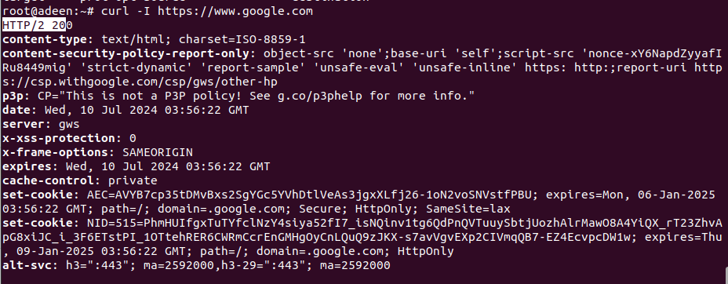

. Verify Access to cti.wazuh.com:

Ensure that the Wazuh manager can reach the feed server.

# curl -I <https://cti.wazuh.com>

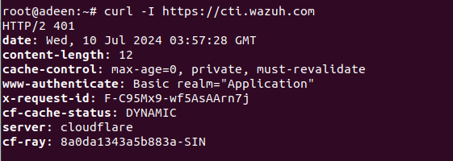

. Firewall and Proxy Settings:

Check if there are any firewall rules or proxy settings that might be blocking the connection. Ensure that outgoing connections to cti.wazuh.com are allowed.

. registered agent or not

**Sol:** change manager ip in agent’s /var/ossec/etc/ossec.conf, it was wrong

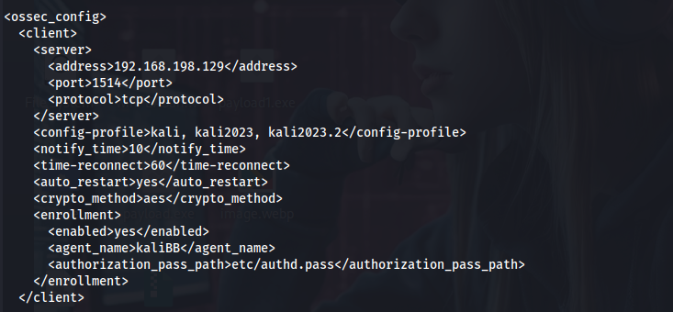

In windows

